
Vivekananda College of Engineering & Technology
[A unit of Vivekananda Vidyavardhaka Sangha, Puttur ®]
Affiliated to Visvesvaraya Technological University, Belagavi
Approved by AICTE, New Delhi & Govt of Karnataka

REPORT ON-ASSIGNMENT-2 WEB TECHNOLOGIES(MMC105)
SMART DIGITAL NOTICE BOARD SYSTEM
“A Centralized, Paperless Platform for Instant Campus Communication”

Submitted To,
Dr. Jothimani K,
Head of the Department,
Dept of MCA,
VCET, Puttur-574203

Submitted by,
Regno: 25MC001 Regno: 25MC029
Name: Adithya Sharma M Name: Pradeeshraj V S
Class: 1 year Class: 1 year
Dept: MCA Dept:MCA
Submitted on,
Date: 19-02-2026

INTRODUCTION & SYSTEM OVERVIEW

TITLE OF THE PROJECT - UniNotice
SMART DIGITAL NOTICE BOARD SYSTEM
“A Centralized, Paperless Platform for Instant Campus Communication”
PAGE 2: INTRODUCTION & SYSTEM OVERVIEW
1. INTRODUCTION The modern healthcare landscape requires efficient digital solutions to bridge the gap between patients and medical specialists. MediBook is a web-based appointment request system designed to streamline the process of scheduling medical visits. It provides a professional interface where patients can select departments and book slots instantly, replacing manual phone-based or walk-in systems.
2. PROBLEM STATEMENT Traditional medical booking systems often suffer from:
- Inconsistent appointment tracking.
- Long waiting times for patient registration.
- Lack of personalized confirmation for patients.
- Difficulty in managing department-specific specialist queues.
3. OBJECTIVES
- To provide a user-friendly digital platform for healthcare booking.
- To implement personalized patient responses using dynamic web technology.
- To organize medical services by specialty (Cardiology, Neurology, etc.).
- To ensure a mobile-responsive experience for users on all devices.

PAGE 3: TECHNOLOGY USED & ARCHITECTURE
4. TECHNOLOGY STACK
- Frontend:
  - HTML5: Structured the booking form and success pages.
  - CSS3 & Bootstrap 5.3: Used for the "Frosted Glass" UI effect, responsive grids, and professional typography.
  - Google Fonts (Inter): For a clean, modern medical interface.
- Interactivity:
  - JavaScript (ES6): Used for date validation (disabling past dates), form submission handling, and URL parameter parsing to personalize the success message.
- Design Elements:
  - Animate.css Logic: Custom CSS animations for card "Slide-Up" effects and background movements.
5. SYSTEM ARCHITECTURE MediBook follows a Client-Side Data Flow model:
- User Input: Patient enters details (Name, Email, Specialty) on the appointment.html page.
- Validation: JavaScript ensures the appointment date is not in the past.
- Data Transfer: Upon submission, data is encoded into URL parameters.
- Dynamic Rendering: The success.html page extracts the patient's name and displays a personalized "Safe Hands" confirmation.

PAGE 4: SYSTEM FEATURES & USER ROLES
6. KEY FEATURES
- Personalized Success Page: Dynamically greets the patient by name upon successful booking.
- Safe Hands Badge: A specialized UI component that provides psychological comfort to the patient.
- Smart Date Picker: Automatically restricts users from picking dates that have already passed.
- Frosted Glass UI: High-end aesthetic using backdrop-filter for a modern, professional look.
- Specialty Selection: Categorized departments for efficient routing.
7. SYSTEM USERS
- Patient: Can view specialist profiles, select departments, and submit appointment requests.
- Medical Staff (Backend Logic): Receives structured data to finalize and confirm the visit via email or phone.

PAGE 5: INTERFACE PREVIEW (Visual Documentation)
(This page represents the visual layout of your application)

Shows Dr. Prasanna Kumar (Cardiologist), Dr. Priya M (Neurologist), etc.

The MediBook Appointment Card with fields for Name, Specialty, and Date.
8. DESIGN PHILOSOPHY The interface uses a High-Quality Clinic Background with a blur filter (4px) and a linear gradient to maintain text readability while providing a professional medical atmosphere. The "Confirm My Request" button utilizes a 135-degree blue gradient for high visibility.

PAGE 6: CONCLUSION & ADVANTAGES
9. ADVANTAGES
- Personalization: Individualized "Thank You" messages improve patient trust.
- Efficiency: Reduces the administrative load on hospital front-desk staff.
- Accessibility: Accessible via Desktop, Tablet, or Mobile devices anytime.
- Safety: Ensures patients feel secure through "Safe Hands" messaging and professional design.
10. CONCLUSION The MediBook system effectively demonstrates the practical application of front-end web technologies in the healthcare sector. By combining Bootstrap's layout power with JavaScript's dynamic capabilities, the project provides a seamless user journey from browsing doctor profiles to receiving a personalized confirmation. This project serves as a robust foundation for a full-scale hospital management system.
© 2026 MediBook Hospital | Healthcare Systems

Home page
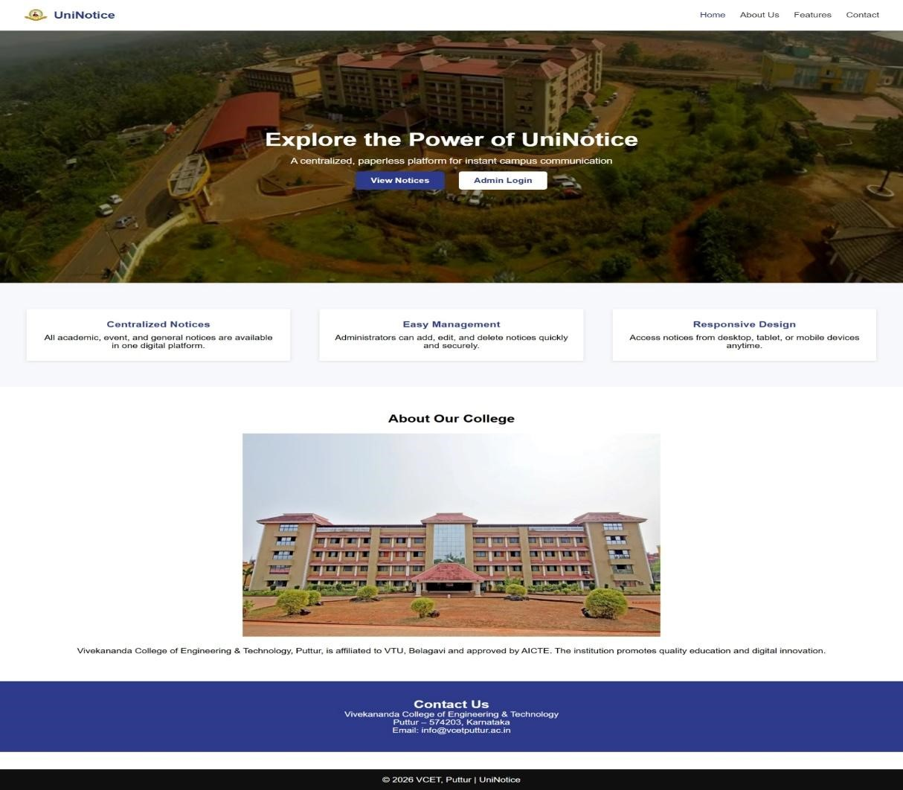

Admin Login page
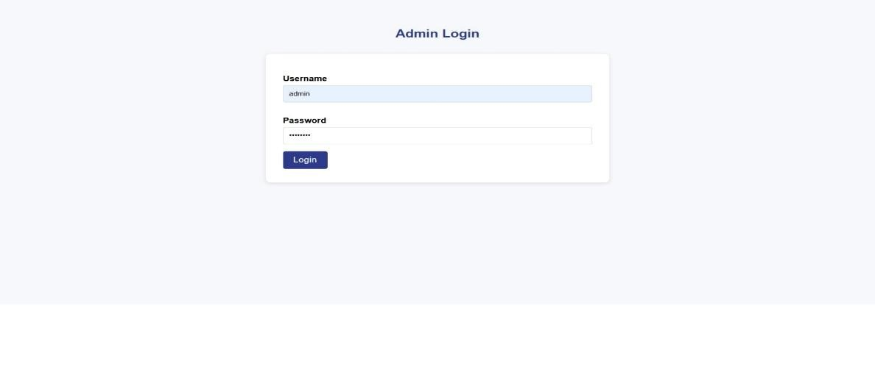

Admin Dashboard
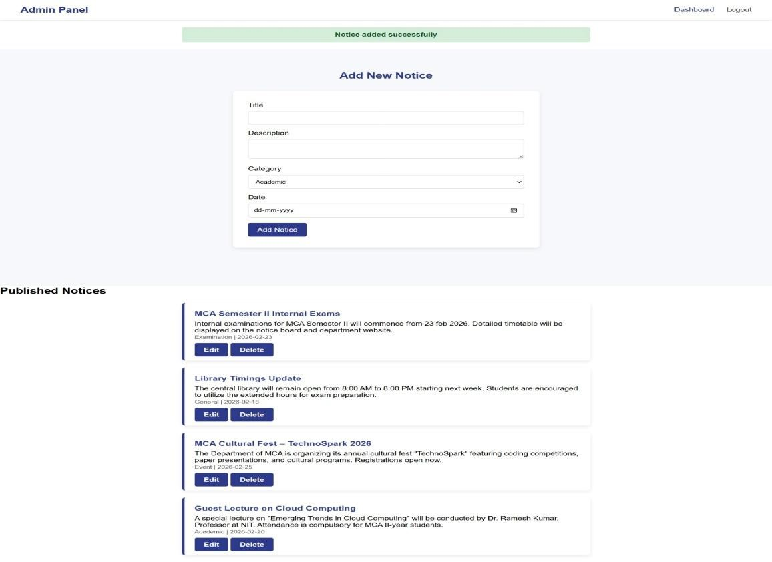

View Notice page
